Get Ready to Read!

Children’s Literature Bibliography
Julie Papperman
SLM 503 Literature for Children
October 19, 2017

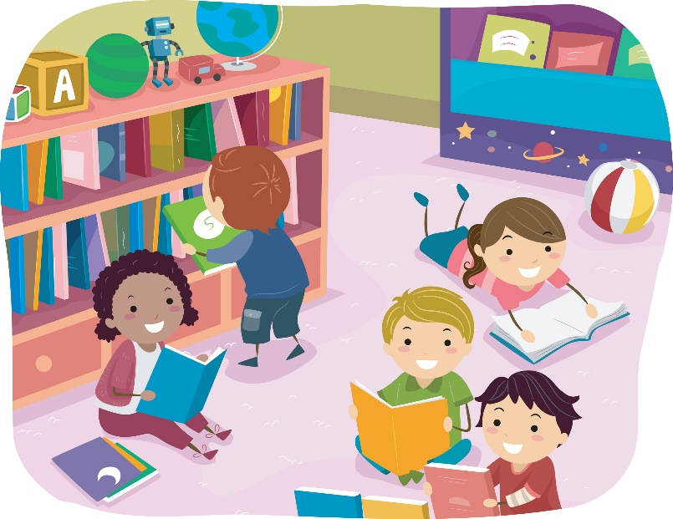
Table of Contents

Letter to Students…………………………………...3
Elementary School Students’ Rights to Read….4
Picture Books and Easy Readers…………………5
Fiction Books…………………………………………11
Nonfiction Books…………………………………….17
Magazines……………………………………………23
Diversity – Insight into Poverty…………………….25
Notes…………………………………………………..27
Dear Students,
Welcome to the library! Getting lost in a book is a true joy of mine. I can escape into another world and experience things I never would anywhere else. Reading also teaches me about our world.
I made this bibliography to share some books that are examples of why I enjoy reading. I hope these books take you to another place like they did when I read them. The bibliography includes picture books, fiction books, nonfiction books, and magazines.
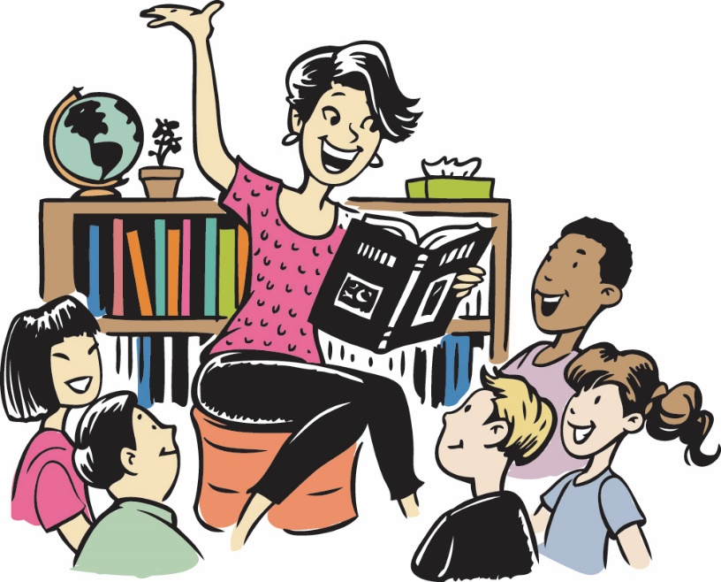
When you are wondering what your next book to read should be, look here for an idea. This is also a great place to search if you want to try a different kind of book. Open your world with reading!

Happy reading,
Mrs. Papperman

Elementary School Library Students’ Rights to Read

You have the right to:
- Come to the library anytime when it is open.
- Borrow a book for as long as you need.
- Have privacy in what you read.
- Ask the librarian for help.
- Choose what you want to read.
- Have a library with a variety of materials about a variety of topics.
- Have access to information from all points of view.
- Think freely and make your own opinions.

Created by using the ideas from ALA Office for Intellectual Freedom documents found at http://www.ala.org/.
Julie Papperman 10/15/2017
Picture Books and Easy Readers

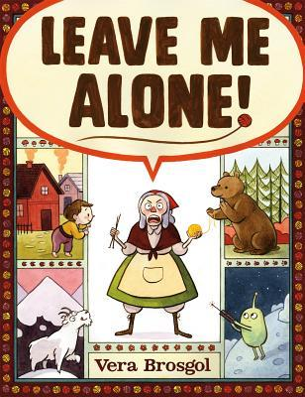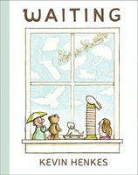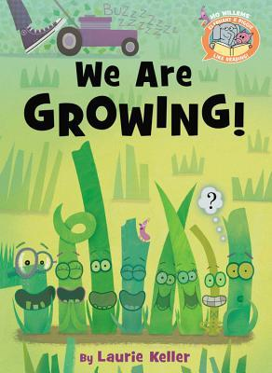
Brosgol, Vera. Leave Me Alone! New York: Roaring Brook, 2016.

An old woman is trying to get her knitting done before winter arrives. Her grandchildren won’t let her. She packs a sack and goes on a search for a quiet empty space. The old woman encounters a family of bears, a herd of goats, and a group of aliens along the way. Once she is finally alone, she might never leave!
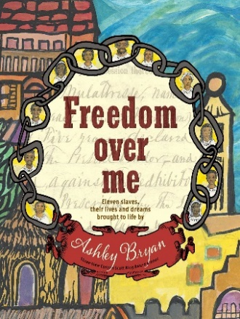 | Bryan, Ashley. Freedom Over Me: Eleven Slaves, Their Lives and Dreams Brought to Life by Ashley Bryan. New York: Atheneum, 2016.  After her husband dies, Mrs. Fairchilds wants to sell her estate. She decides to return to England where she feels safe. The estate includes eleven Negro slaves. Each slave tells about how he or she arrives and works at the Big House. Even though the slaves have jobs to do, they also have dreams of a different life.
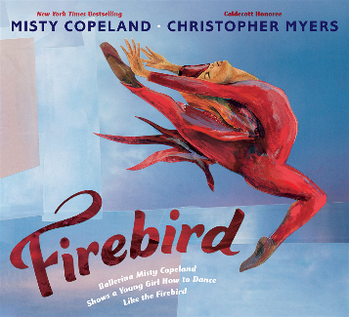 | Copeland, Misty. Firebird: Ballerina Misty Copeland Shows a Young Girl How to Dance Like the Firebird. New York: Putnam, 2014.  A young girl is learning ballet. She becomes discouraged as she practices. Misty Copeland, a ballerina, shares her struggles with the girl. Misty sweats at the barre. She has many falls. Misty tells the dancer that with determination, she can be center stage.
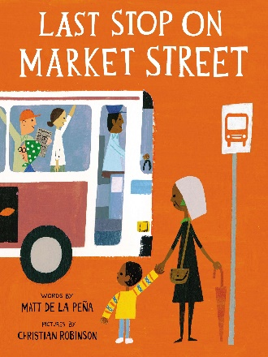 | de la Peña, Matt. Last Stop on Market Street. New York: Putnam, 2015.  After church, CJ and Nana get on the bus. When CJ notices two boys with an iPod, he wishes he had one as well. Nana replies that a real guitar player is sitting right there on the bus. CJ asks why is the street so dirty. Nana comments you can see the beauty better among the dirt. Maybe CJ will see the beauty in the world like Nana.
Henkes, Kevin. Waiting. New York: Greenwillow, 2015.

Five toys are sitting on a windowsill. They are waiting for the rain, wind, snow, moon, and even nothing at all. As time goes by, the friends see marvelous things like a rainbow, fireworks, and gifts. Eventually, a new friend is introduced to them. The toys are surprised when they find out what she has been waiting for.
Keller, Laurie. We Are Growing! New York: Hyperion, 2016.

Several blades of grass are growing. One notices it is the tallest. Another one determines it is the pointiest. One finds out it is the crunchiest. Everyone is special except for Walt! He must find his uniqueness.

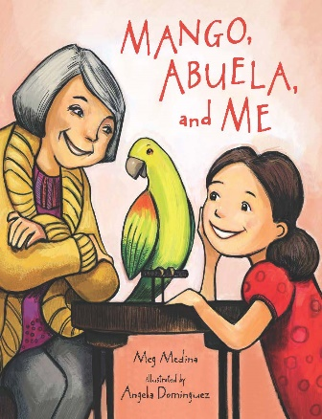 | Medina, Meg. Mango, Abuela, and Me. Somerville, MA: Candlewick, 2015.  Mia’s grandmother, Abuela, is coming to live with her! There is just one problem. Her grandmother speaks Spanish. Mia decides to teach Abuela English. They practice naming things around their home. One day, Mia brings home a parrot. The parrot becomes helpful in a special way.
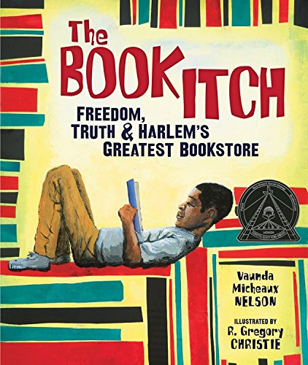 | Nelson, Vaunda. The Book Itch: Freedom, Truth, and Harlem’s Greatest Bookstore. Minneapolis, MN: Carolrhoda, 2015.  Lewis’ family owns the National Memorial African Bookstore. Rallies are held at the store. People come to talk about equal rights for blacks. When Malcom X comes to speak, Lewis listens to his words. Later, Lewis learns Malcom X has been killed. Now he understands the importance of the bookstore.
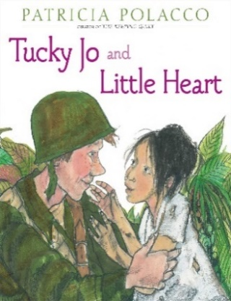 | Polacco, Patricia. Tucky Jo and Little Heart. New York: Simon & Schuster, 2015.  World War II has begun. Johnnie Wallen enlists in the army. He is stationed in the Philippines. Johnnie meets a little girl from the village. They end up helping each other. The jungle is going to be firebombed! The soldiers rush to save the villagers. Johnnie never sees the girl again. Years later their paths remarkably cross again.
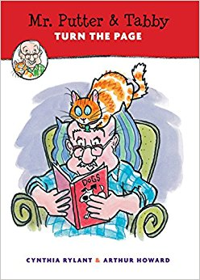 | Rylant, Cynthia. Mr. Putter and Tabby Turn the Page. Boston: Houghton Mifflin Harcourt, 2014.  Mr. Putter loves to read to his pet cat, Tabby. One day, the library advertised a story time with pets. Mr. Putter decided Tabby and he would go. Mrs. Teaberry, his neighbor, decides to go too. Mr. Putter starts to worry because her dog might get too excited. Sure enough, Zeke, Mrs. Teaberry's dog, runs out of the library. Yikes!
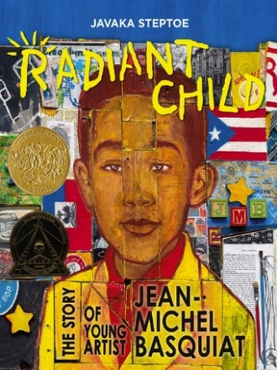 | Steptoe, Javaka. Radiant Child: The Story of Young Artist Jean-Michel Basquiat. New York: Little, Brown, 2016.  Young Jean-Michel Basquiat draws all the time. He wants to be a famous artist. His mother teaches him that art is everywhere. It is in the museums, in words people say, and on the streets. As he grows up, Jean-Michel paints graffiti around the city. Other artists notice his work. Jean-Michel is finally famous! Still, there is one person he honors the most.
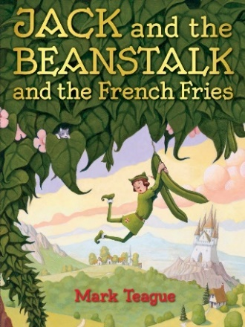 | Teague, Mark. Jack and the Beanstalk and the French Fries. New York: Orchard, 2017.  Jack and the rest of the town have only beans to eat. Angry there is not any other food, the people come after Jack. He climbs the beanstalk to escape and arrives at the giant's castle. The giant is also very grumpy from eating only beans. The giant and Jack work on a solution they hope will make the people happy.
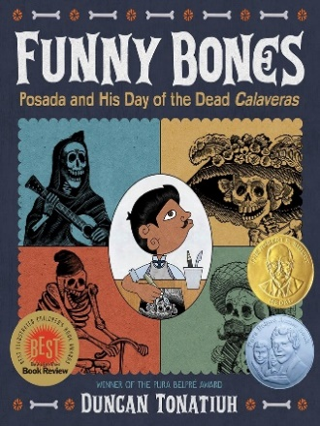 | Tonatiuh, Duncan. Funny Bones: Posada and His Day of the Dead Calaveras. New York: Abrams, 2015.  Skeletons can be scary, but Lupe Posada made them fun. He grew up in Mexico and enjoyed drawing as a child. When he was an adult, Lupe began to draw skeleton pictures called calaveras. He created them for the Day of the Dead holiday. Lupe became an expert and made them all the time. They told his views of the world.
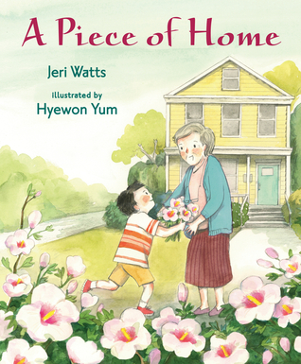 | Watts, Jeri. A Piece of Home. Somerville, MA: Candlewick, 2016.  Hee-Jun discovers moving is not easy. His dad accepts a job in West Virginia. The family leaves everything familiar to them in Korea. Now in a new country, Hee-Jun doesn't fit in with the other kids. His grandmother is sad. His sister is acting out. Maybe a teacher and a new friend can help.
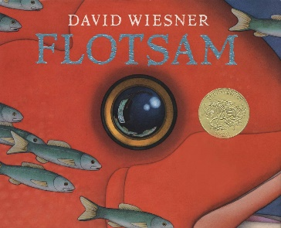 | Wiesner, David. Flotsam. New York: Clarion, 2006.  A boy sits on the beach studying a crab. An old underwater camera washes up. After the film is developed, the boy sees amazing photos. The camera has been shared for years. The boy adds his picture. He tosses the camera back in the ocean. Someone else can now discover this treasure.
Fiction Books

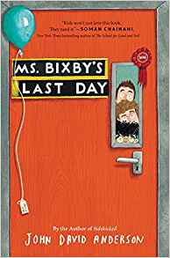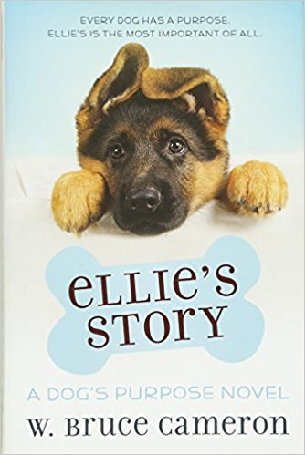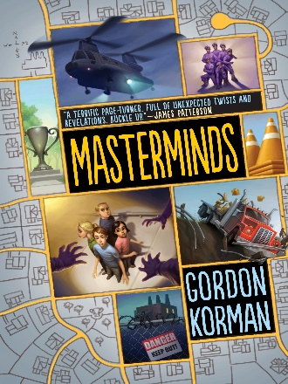
Anderson, John David. Ms. Bixby’s Last Day. New York: Walden Pond, 2016.

Brand, Topher, and Steve have the same teacher, Ms. Bixby. As far as teachers go, Ms. Bixby is one of the “Good Ones.” Ms. Bixby announces she has cancer and cannot finish the school year. The three friends plan to skip school and take a few of Ms. Bixby’s favorite things to her hospital room. It is risky, but their teacher is worth it.
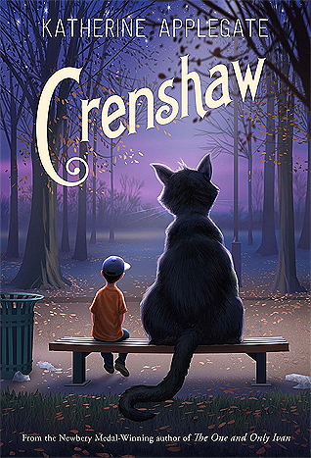 | Applegate, Katherine. Crenshaw. New York: Feiwel & Friends, 2015.  Jackson’s old imaginary friend, Crenshaw, returns. Jackson does not want Crenshaw around. Jackson’s family is running out of money. Little food is in their kitchen cabinets. Many of their things have been sold. They might lose their apartment. Jackson is upset. Crenshaw knows how to help.
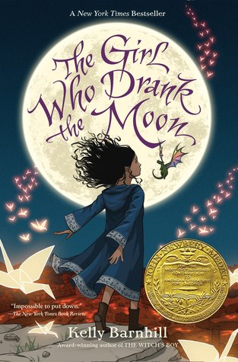 | Barnhill, Kelly. The Girl Who Drank the Moon. Chapel Hill, NC: Algonquin, 2016.  The people of the Protectorate sacrifice a baby to the witch each year. They believe this will save them from the witch. They don’t realize the witch, Xan, is friendly. One night, Xan accidentally pours magic into a baby girl. Years later, the girl, Luna, learns of the magic she never knew she had. Now, Xan is in danger. Luna must use her magic to protect Xan.
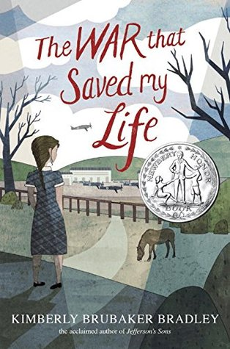 | Bradley, Kimberly Brubaker. The War that Saved My Life. New York: Dial, 2015.  It is World War II. London’s children are being evacuated to the country. Mam allows her young son, Jamie, to go, but refuses to let her crippled daughter, Ada, go. So, Ada sneaks away. While away, Ada makes a friend and helps soldiers. Later, Mam takes Ada and Jamie back. Ada makes sure they will leave Mam for good this time.
Cameron, W. Bruce. Ellie’s Story: A Dog’s Purpose Novel. New York: Starscape, 2015.

Ellie loves work. Getting to “Find” is a very important job. Ellie is an excellent search and rescue dog. On an assignment, Ellie becomes very determined to save the trapped human. During this job, she damages her most valuable tool, her nose. No more work for Ellie, or so she thinks.
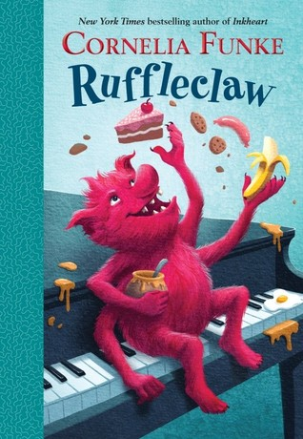 | Funke, Cornelia. Ruffleclaw. New York: Random House, 2015.  An earth monster, Ruffleclaw, lives in the ground under Tommy’s shed. Ruffleclaw decides to live in the humans’ house. He enjoys the sound of the piano. One morning, Tommy meets Rufflecaw. The monster spits, drinks the shampoo, and eats all the cake. However, Tommy decides to keep Ruffleclaw. He just needs to get his parents to agree.
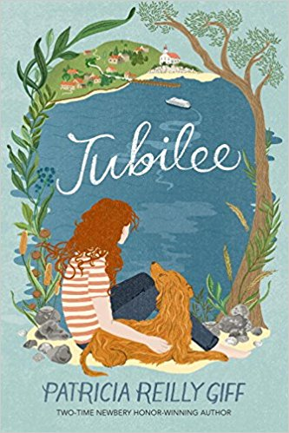 | Giff, Patricia Reilly. Jubilee. New York: Wendy Lamb, 2016.  As a toddler, Judith's mother gave her to Aunt Cora to raise. Ever since that time, Judith has not spoken. She draws or writes on her pad to communicate. The other children do not accept Judith. More than anything, Judith wants to speak. She discovers her mom lives nearby and goes to visit her. Maybe now she will be able to talk.
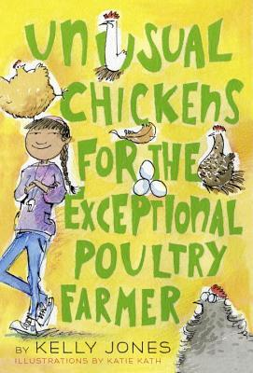 | Jones, Kelly. Unusual Chickens for the Exceptional Poultry Farmer. New York: Alfred A. Knopf, 2015.  Sophie has moved to Great-Uncle Jim’s old farm. Great-Uncle Jim has passed away. Sophie writes letters to him and her grandmother, who also has passed away. She shares she has found chickens with super powers. She learns how to care for them. When Sophie finds out someone is trying to steal the chickens, she works to keep them out of harm’s way.
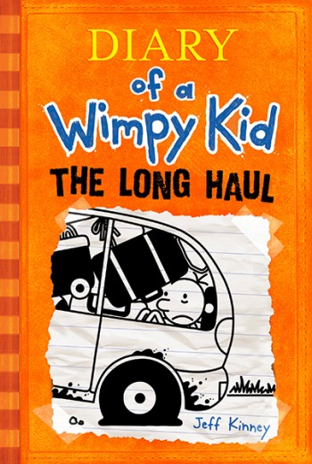 | Kinney, Jeff. Diary of a Wimpy Kid: The Long Haul. New York: Amulet, 2014.  It is summer vacation. Greg’s mom surprises the family with a road trip. Surprise trips have a history of not going well. This trip seems no different. Greg sleeps in the hotel closet. Manny, Greg’s brother, wins a piglet. Seagulls invade the van. Trying to still have fun, the family goes to a waterpark. Their biggest adventure is awaiting!
Korman, Gordan. Masterminds. New York: Balzer + Bray, 2015.

Serenity, New Mexico is a small town. It has no crime and no poverty. It is kept in perfect condition. Eli’s friend warns him things seem "screwy.” Eli becomes suspicious. He finds out kids are being studied. They can't trust anyone. The community is a human behavior experiment that uses clones. Eli and his friends decide they must escape.
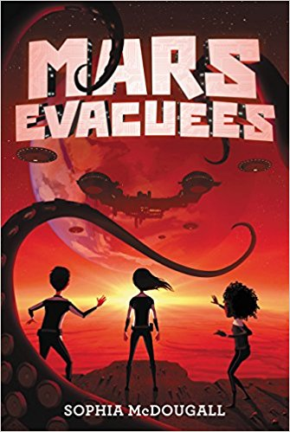 | McDougall, Sophia. Mars Evacuees. New York: Harper, 2015.  Earth has been at war with aliens for fifteen years. To save the planet, the EEC is sending children to Mars to train in space combat. Alice Dare gets to go. After a space locust attack, the adults at Beagle Base on Mars disappear. Then Alice and her friends capture an alien. Both species realize they need to cooperate with each other to survive.
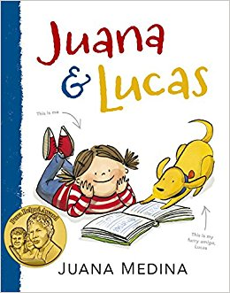 | Medina, Juana. Juana and Lucas. Somerville, MA: Candlewick, 2016.  Juana lives in Bogotá, Colombia. She loves all kinds of things, including Brussels sprouts. Juana finds out she is going to learn English. Juana does not like English. She asks people why she should learn it but does not think the reasons are good. Juana’s grandfather gives her a special reason to learn English. Now Juana can’t wait to speak it!
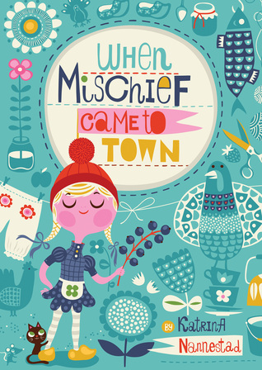 | Nannestad, Katrina. When Mischief Came to Town. New York: Houghton Mifflin Harcourt, 2016.  Inge Maria’s parents have died. She must leave Copenhagen to live with her grandmother in Bornholm. The townspeople are strict compared to the people back home. Trouble often finds Inge Maria. She knocks a turkey in the head, gets mud on the clean laundry, and dances in school. Inge Maria soon brings joy to the people of Bornholm.
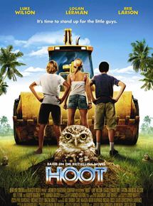 | Shriner, Wil. Hoot. DVD. Directed by Wil Shriner. Burbank, CA: New Line Cinema, 2006.  Roy is the new kid in town. He just moved from Montana to Florida. While riding the school bus, Roy sees a barefoot boy outside running down the sidewalk. Roy discovers the boy is trying to stop a pancake house from being built. The site of the restaurant is the home of burrowing owls. The developer refuses to let anything or anyone get in his way.
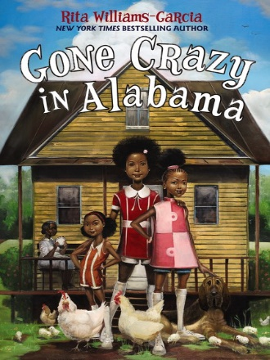 | Williams-Garcia, Rita. Gone Crazy in Alabama. Audiobook. New York: Harper Audio, 2015.  Delphine, Vonetta, and Fern travel to Alabama to visit family: Big Ma and Ma Charles. The three sisters hear stories about their family. They learn why Ma Charles does not speak to her half-sister. One morning, Vonetta disappears on a bicycle. A tornado hits. No one can find her. The family must come together for support.
Nonfiction Books

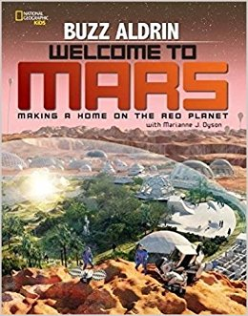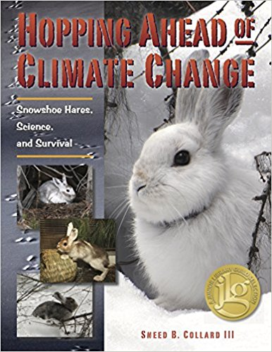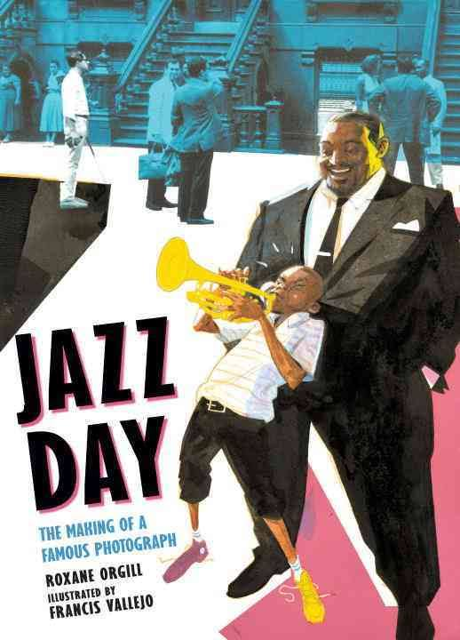
Aldrin, Buzz, and Marianne J. Dyson. Welcome to Mars: Making a Home on the Red Planet. Washington, DC: National Geographic Kids, 2015.

Buzz Aldrin explains how living on Mars can be possible. Homes will be built under the ground and near the equator. Greenhouses will give people food and oxygen. Heating the ice on Mars will make water. Solar, wind, and geothermal energy will give people electricity. Mars could be your new home!

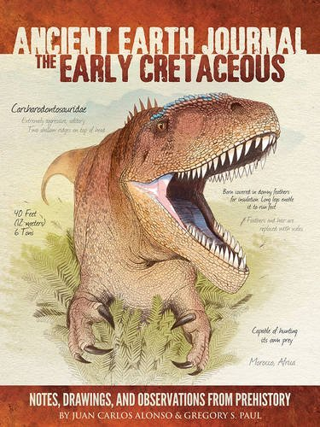 | Alonso, Juan Carlos, and Gregory S. Paul, Ancient Earth Journal: The Early Cretaceous: Notes, Drawings, and Observations from Prehistory. Lake Forest, CA: Walter Foster Jr., 2015.  Explore dinosaurs and birds from the Early Cretaceous Period. Theropods are the great hunters. They have teeth up to eight inches long. Sauropods can be longer than one hundred feet. Ornithischians have body armor, horns, and frills. Pterosaurs are flying fish-eating creatures. The first birds share some traits with the dinosaurs.
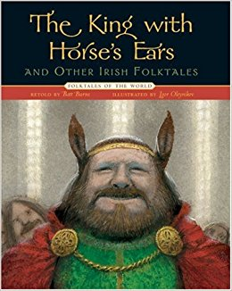 | Burns, Batt. The King with Horse’s Ears and Other Irish Folktales. New York: Sterling, 2009.  Storytelling is an Irish tradition. One tale tells how a young thief tricks a master thief. Meet a leprechaun that avoids being caught by a human. Discover a place where no one grows old and an island where the people are turned into seals.
Collard III, Sneed B. Hopping Ahead of Climate Change: Snowshoe Hares, Science, and Survival. Missoula, MT: Bucking Horse, 2016.

Biologist Scott Mills has noticed some snowshoe hares have white fur when spring begins. They are becoming easier prey. Through his studies, Scott found that climate change is the cause. His team of scientists are studying the hares’ genes to keep their population from declining. There are ways you can help too!
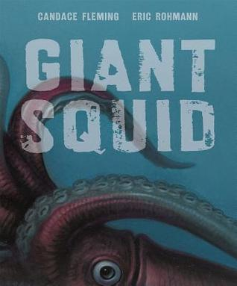 | Fleming, Candace. Giant Squid. New York: Roaring Brook, 2016.  Facts about the Giant Squid are described through a poem. The squid lives very deep in the ocean. It has two big eyes, two tentacles, and eight arms. It has suckers with sharp teeth that grab its prey. Its meal enters its beak onto a tongue covered with tiny blades. A predator, the barracuda, swims close. The Giant Squid sprays ink to escape.
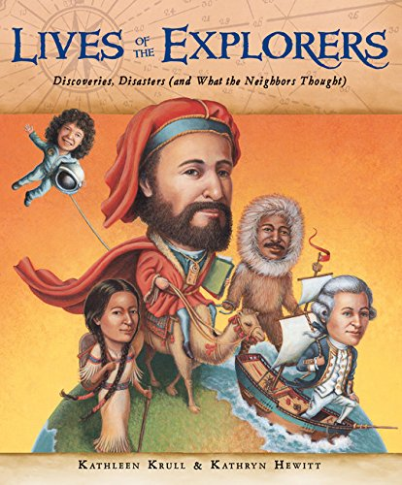 | Krull, Kathleen. Lives of the Explorers: Discoveries, Disasters (and What the Neighbors Thought). Boston, MA: Houghton Mifflin Harcourt, 2014.  Explorers discovered many things. Some of them were liked and some were not. Marco Polo was called “Marco Millions.” People thought he told many lies about his trips. Matthew Henson was called “Matt, the Kind One” by the people living in the artic region. One explorer was cruel to his crew. He was arrested and put in prison!
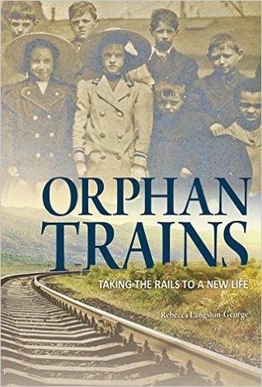 | Langston-George, Rebecca. Orphan Trains: Taking the Rails to a New Life. North Mankato, MN: Capstone Young Readers, 2016.  Trains took orphaned children from New York City to the Midwest. The children were taken in by families. A boy, Arthur, found new parents who raised him as if he were their own son. However, a girl, Agnes, had her new mother lock her in the cellar for crying. The orphan trains stopped running in 1929. The trains led to the idea of today's foster care system.
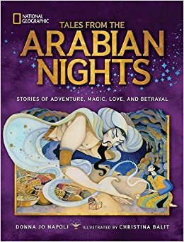 | Napoli, Donna Jo. Tales from the Arabian Nights: Stories of Adventure, Magic, Love, and Betrayal. Washington, DC: National Geographic, 2016.  The king, Shah Rayar, decides to take a wife each day and have her killed the next morning. Scheherazade tries to stop the king when she becomes his wife. She plans to tell him a story each night. The stories leave him wanting to hear more. After a thousand and one nights, the king chooses if he will keep Scheherazade as his wife or kill her.
Orgill, Roxane. Jazz Day: The Making of a Famous Photograph. Somerville, MA: Candlewick, 2016.

An invitation is sent to jazz musicians in New York City. Art Kane wants to take a picture of them for Esquire magazine. On the day of the photo shoot, musicians slowly arrive. They greet and talk with each other. With time, everyone finds a spot to stand. Some neighborhood boys line the front row. Snap! The picture is taken.
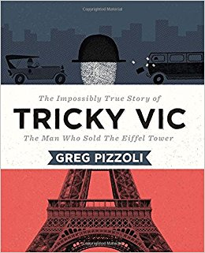 | Pizzoli, Greg. Tricky Vic: The Impossibly True Story of the Man Who Sold the Eiffel Tower. New York: Viking, 2015.  Robert Miller grew up in the Czech Republic. He quit school and began his career as a con artist. Robert became well known. He did business with Al Capone and tricked André Poisson into buying the Eiffel Tower. After two arrests, Robert was caught for good!
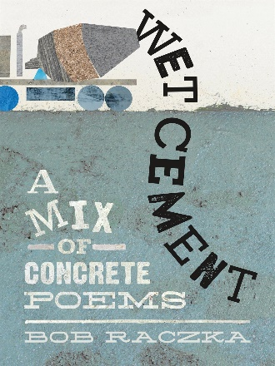 | Raczka, Bob. Wet Cement: A Mix of Concrete Poems. New York: Roaring Brook, 2016.  Poems in this collection take the shape of its subject. In “Clock,” the words circle around to form the shape of a clock. The words tilt and topple onto each other in “Dominoes.” In “Icicle,” the words dangle from the top edge of the pages. The words zigzag down across the page in one of the last poems.
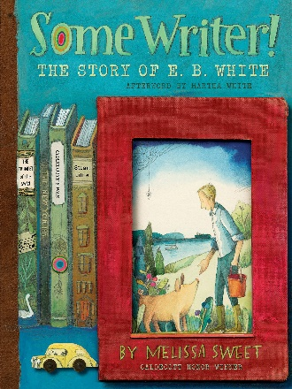 | Sweet, Melissa. Some Writer! The Story of E.B. White. Boston, MA: Houghton Mifflin Harcourt, 2016.  E.B. White loved to write. Growing up, he wrote in a journal, for magazine contests, and for his high school’s newspaper. As an adult, he wrote for The New Yorker magazine. Later, White decided to write children’s books. He based Charlotte’s Web on his farm he lived on. He never lost his love for writing. White believed a writer’s job is to show his love for life.
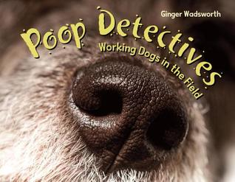 | Wadsworth, Ginger. Poop Detectives: Working Dogs in the Field. Watertown, MA: Charlesbridge, 2016.  Scientists who study endangered animals need help. They use dogs trained to sniff scat. The dogs work in forests, deserts, mountains, and water. Some dogs go to Cambodia and Nigeria. They search for tigers and gorillas. When the dogs are about nine years old, they stop working. Then some dogs get to enjoy being a family pet!
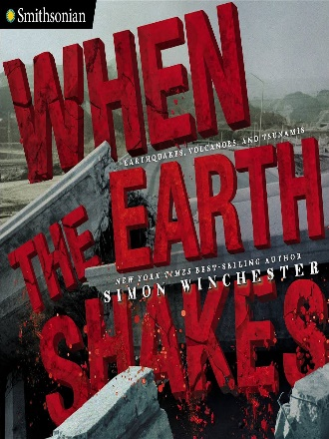 | Winchester, Simon. When the Earth Shakes: Earthquakes, Volcanoes, and Tsunamis. New York: Viking, 2015.  When the ground moves, earthquakes, volcanoes, and tsunamis can cause destruction. They damage homes and lives. Sometimes warnings help people stay safe. Scientists continue to study these natural disasters. After being in an earthquake and on a volcano, Simon says natural disasters are a reminder of how fragile Earth is.
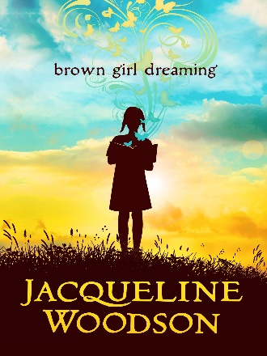 | Woodson, Jacqueline. Brown Girl Dreaming. New York: Nancy Paulsen, 2014.  Jacqueline Woodson shares her poems about growing up. Jackie grew up during the civil rights movement. She lived in the South with her grandparents. Later, she moved to New York with her mom. Jackie always wanted to be a writer. One day, her teacher read one of her poems. When the teacher told her she was a writer, Jackie knew her dream could come true!
Magazines

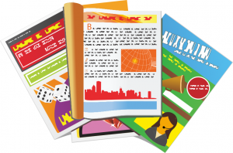

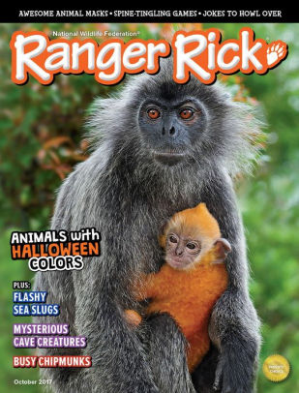
American Girl. http://play.americangirl.com/play/magazine/

Read about how girls have helped in their community. Get advice from adults and peers on topics such as bullying and friendship. Find articles, puzzles, contests and craft ideas in each issue. Check out the website that has quizzes, videos, and games.
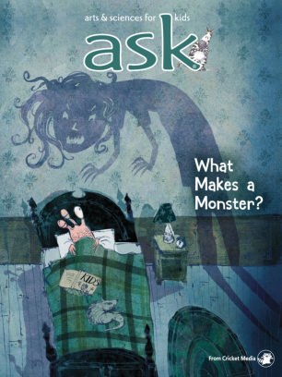 | Ask. http://shop.cricketmedia.com/ASK-Magazine-for-Kids.html  Find answers to questions about our world. “How did whales become whales?” “Why do we love sweets?” Each issue includes facts, pictures, stories, and hands-on activities about a science topic. Read letters from kids and enter in a contest!
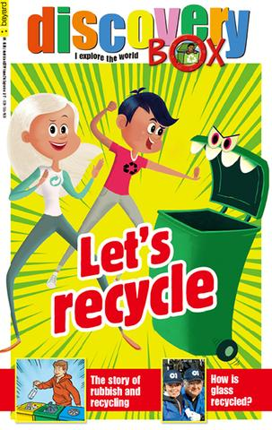 | Discovery Box. https://bayardkidsonline.com/collections/discovery-box/products/discovery-box  If you like science, animals, and history, then Discovery Box is for you! Learn with other kids as they explore a topic. An experiment, pet care tips, comic strips, and articles are found in each issue.
Ranger Rick. https://kids.nwf.org/Kids/Ranger-Rick.aspx

Learn about saving nature through the adventures of a raccoon named Ranger Rick. Each issue has articles, photos, jokes, and puzzles. Find videos, games, and a photo contest online. Do not miss a chance to ask Ranger Rick a question!
Sports Illustrated Kids. https://www.sikids.com/

Athletes and the world of sports is covered in Sports Illustrated Kids. Each issue has articles about staying healthy and tips from athletes to improve skills. Read about Olympic and kid athletes too. The website includes videos and games to enjoy.
Diversity:
Insight into Poverty

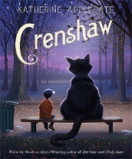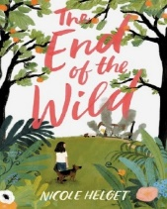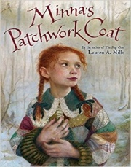

Diversity: Insight into Poverty

Created by Julie Papperman on October 18, 2017

Almost half of children in the United States come from low-income families. Their parents may or may not have a job. Their parents might be married or single. These five books show that children in poverty want to belong, want to be successful, and want to do good. They are like anyone. Children in poverty can make a difference in their own lives and others’ lives.

Applegate, Katherine. Crenshaw. New York: Feiwel & Friends, 2015.

Jackson’s old imaginary friend, Crenshaw, returns. Meanwhile, Jackson’s family is running out of money. Little food is in their kitchen cabinets. Many of their things have been sold. They might lose their apartment. Jackson is upset. Crenshaw knows how to help.
Helget, Nicole. The End of the Wild. New York: Little, Brown, 2017.

Eleven-year-old Fern lives in a small run-down house in the woods. Her family uses the plants and animals in the woods for food. They do not have money to buy food. A fracking company threatens to get rid of the grove. Her STEM project might be the answer to her problems.
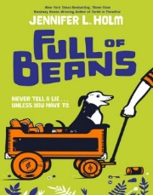 | Holm, Jennifer L. Full of Beans. New York: Random House, 2016.  Beans Curry lives in Key West, Florida in 1934. His dad is looking for a job in New Jersey. Beans decides to work for Johnny Cakes to help earn money. However, the jobs turn out to be too risky. Instead, Beans decides to help with the town’s cleanup effort. Tourists are coming, and Beans finds the perfect job.
Mills, Lauren A. Minna’s Patchwork Coat. New York: Little, Brown, 2015.

Minna wants to go to school, but needs a coat to attend. Her papa says he will get her a coat, but he passes away before he can. The mothers of children at school sew a coat for Minna from patches of clothes. When Minna goes to school, she shares how her coat was made. The children learn an important lesson.
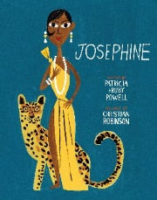 | Powell, Patricia Hruby. Josephine: The Dazzling Life of Josephine Baker. San Francisco, CA: Chronicle, 2014.  Josephine lived in the slums of St. Louis. Dancing made Josephine happy. At fifteen, Josephine went to New York to dance. She sent her family money she earned. When she moved to Paris, Josephine became famous. She danced in good and bad times for the rest of her life.

Wilson’s Core Collection of Most Highly Recommended Books and the Notable Social Studies Trade Books for Young People were used to select books. Information in the top paragraph is from:
Jiang, Yang, et al. “Basic Facts about Low-Income Children: Children 6 through 11 Years, 2015.” National Center for Children in Poverty, Jan. 2017, http://nccp.org/publications/pub_1173.html.
Notes
Sources Used to Select Materials

Google Image was used to search for all books, movies, magazines, and clipart images.
ALSC Children’s Notable Books List | The Association for Library Service to Children creates this list each year. It names the most outstanding children’s books for the year.
Caldecott Award List  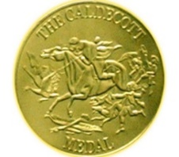 | The Caldecott Medal is awarded to the artist who illustrated the most distinguished picture book of the year. It is an American award given each year by the Association for Library Service to Children. The recipient must be a U.S. citizen or resident.
Coretta Scott King Award List  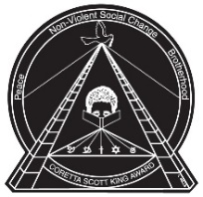 | Each year the Ethnic and Multicultural Information Exchange Round Table of the American Library Association gives the Coretta Scott King Award to African American authors and illustrators. The authors and illustrators that get the award have created the most outstanding books that show appreciation for African American culture for children and young adults.
Geisel Award List  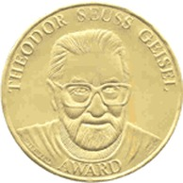 | The Theodor Seuss Geisel Award is given to the authors and illustrators that create the most distinguished American books for beginning readers. The books must be published in English in the United States. The Association for Library Service to Children gives the award each year.
Kaufman, Rebekah | Library Media Specialist at Catonsville Elementary School in Baltimore County, MD.
Kerby’s Quick List | Dr. Ramona Kerby created a list of excellent authors and illustrators of children’s books. She is the coordinator of the School Librarianship program at McDaniel College.

Newbery Award List  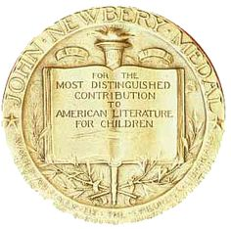 | The Association for Library Service to Children gives the Newbery Medal to the author that writes the most distinguished American children’s book. The medal is awarded each year.
Notable Social Studies Trade Books for Young People  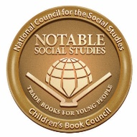 | The National Council for the Social Studies and the Children’s Book Council create this list each year. The list includes books for children in kindergarten through eighth grade. These high-quality books reflect diversity, a variety of cultural experiences, and human relations.
Outstanding Science Trade Books for Students K-12  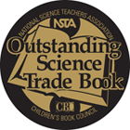 | The National Science Teachers Association and Children’s Book Council create this list each year. It includes the highest quality science trade books for children in kindergarten through twelfth grade.
Parents’ Choice Award Winners: Magazines  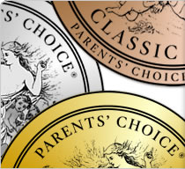 | The Parents’ Choice Awards committee recognizes the best magazines for children. The committee includes educators, scientists, performing artists, librarians, parents, and kids. Each year magazines receive either a Classic, Gold, Silver, Recommended, Approved, or Fun Stuff award.
Pura Belpré Award List  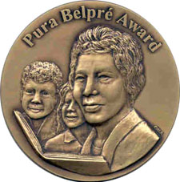 | The Pura Belpré Award is given each year to the most outstanding book that celebrates Latino culture for children and youth. The Association for Library Service to Children and REFORMA, the National Association to Promote Library and Information Services to Latinos, gives the award to the book’s author and illustrator.
Wilson’s Children’s Core Collection of Most Highly Recommended Books | This database lists highly recommended books for children. A group of expert librarians for children choose books to be included.

